PART TWO—UNIT CONCEPTS, GOALS, OBJECTIVES

I used a multi-disciplinary abstract-to-concrete method based on Dale’s Cone of Experience to plan the direction of my unit instruction. Since all unit outcomes were prescribed by the teacher’s manual, I looked for something that I could add that would still allow students to achieve the outcomes. The text served as a basic guide. I decided that whatever I teach about forests, a field trip would be a necessary capstone to provide the most realistic and direct experience possible to conclude the unit. To see, hear, touch, smell the forest is crucial to a complete understanding of the forest eco-system. In my estimation, it is up to the teacher to find his or her own path through the material to meet the prescribed objective and outcomes. Our school’s geographic location permits abundant sample collecting from at least two of the forests covered in this unit. Unfortunately, the rain forest experience must be less direct and concrete in this unit.

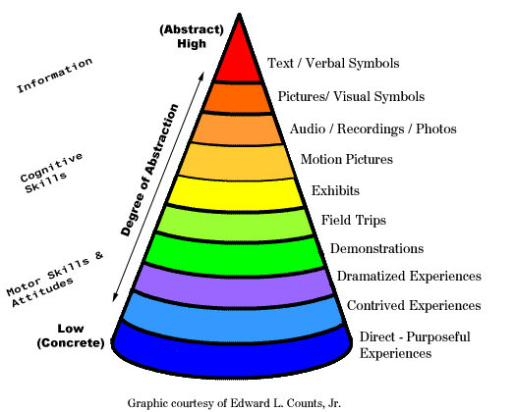

The Outline of the Unit EXPLORING FORESTS

Day 1/Lesson 1 – Introduction to the unit and pre-test administration. KWL students on forests and what they represent, since it’s likely that every student has stood in a forest at some point in their lives. This lesson is the most symbolic and abstract. Just one physical object for the anticipatory set—the pine cone—is used. Many ideas about what a forest actually represents are shared. The pre-test compiled all those thoughts and ideas into an assessment.

Day 2/Lesson 2 – Rainfall and Climate – this lesson features 2D word maps that required students to color code geographic locations where heavy rainfall, heavy forestation, and different climates occur. The color coded areas were to be compared and connections were to be made concerning the relationship between rainfall, climate, and forest growth. The Use of maps made this lesson less abstract as lesson 1. The use of crayons or colored pencils in this lesson was a prelude to the more extensive use of art materials over the next three lessons. Social studies are incorporated in a discussion as to why some areas of high rainfall and tropical climate have no forest growth. Mankind’s influence on the environment has implications affecting their community, via industrialization and commercialization of the rain forest raw resources.

Day 3 -- “Rain Forest and Climate” quiz

Day3/Lesson 3 – Introduction to Deciduous forests. More tree samples with greater detail are shown to class. Different varieties of leaves, ferns, wild flowers, are shown to illustrate forest layers are shown as the anticipatory set and used throughout the lesson as a reference. Samples are also distributed to the class to touch and observe more closely More samples means less abstraction. More physical contact means less abstraction. The lesson includes worksheet questions and a task to illustrate deciduous forest layers. This activity incorporated art skills.

Day 4/Lesson 4 – Introduction to Coniferous forests. This lesson followed the same structure as Lesson 3. I believe there was a need to establish consistency in learning the three types of forests, so the sequence of instruction matched the previous day’s sequence. Coniferous forest samples are shown and distributed. The lesson concluded with worksheets questions and a task to illustrate the coniferous forest layers. This activity incorporated art skills. Students are also asked to make comparisons to deciduous forests

Day 5/Lesson 5 – Introduction to Rain forests. Since I had no physical objects, I used web-based graphics and Quicktime movies to provide the anticipatory set. The music mixed into the background of the slides was indigenous tribal music. This all is another step up toward the concrete/cognitive end of Dale’s Cone of Experience. The sequence remains the same as Lessons 3 and 4. Students will again answer worksheet questions and illustrate the rain forest layers. Again, students are asked to make comparisons with the previous coniferous and deciduous forests. The consistency of the worksheet strategy with the similarly worded questions and the follow up illustration hopefully makes learning about three elements more easy, instead of treating each type of forest to a different styled lesson.

Day 6 -- “Forest Types” quiz

Day 6-7/Lesson 6 – Variety of forests and bean sorting – I changed the order of this lesson from how it was presented in the teacher’s manual. Instead of using this lesson prior to the introduction to the greater varieties of species indigenous to the rain forest, I used it to reinforce the contrast among all three forests. A math application of counting to and over 100 is used, as it is not uncommon to have to sort and classify over two hundred beans. To help lower ability learners, they were teamed up with higher ability learners in the sorting and classification. This was necessary to complete the lesson in two days. The first day the students sorted, classified, and counted the beans that represented the deciduous and coniferous forests. The second day, the beans representing the rain forest were handled the same way. This lesson involves higher cognitive thinking because the beans are symbols of forest varieties.

Day 8/Lesson 7 – Food Chains – now that the students have hopefully understood the comparisons and contrasts among all three forest types, they can build upon that knowledge by learning about the forest eco-systems and food chains. Again, social studies are applied in discussing whether or not forest ecosystems are reminiscent of human communities. The concept of what constitutes a community is discussed, whether it be human or plant or animal. More art skills are applied to illustrating a simple four step forest food chain.

Day 9/Lesson 8 – Building a Terrarium – moving further from abstract to concrete, a live forest model will now be constructed based on knowledge from past lessons. Forest layers are already known. Eco-systems and communities have been introduced. Now combine that knowledge into the creation of an actual small scale community with living and non-living items that could be found in a forest. Plants of different sizes represent different layers. Low grade insect life is introduced to represent animal life. Grass is planted to show growth and provide food for insects. The terrarium observations incorporate language arts as two writing samples will be collected and graded based on raw data gathered over a two week period

Day 10/Lesson 9 – Field Trip Briefing – Organization of this lesson is critical, so an entire class period is devoted to outlining procedures that will be followed in the field. The next step toward higher cognition and concreteness is used with the DVD movie of walking through a deciduous and coniferous forest. The forests depicted on the DVD are identical to the ones that will be visited during the field trip. A field trip is the next step above creating a model, which will lead to direct experiences.

Day 11/Lesson 10 – Field Trip/Nature Walk—the capstone of this unit plan. This lesson combines all previous knowledge into a direct experience outside the classroom. Students observe aspects of the forest community, its living and non-living things, how deciduous leaves transfer water, and various tree layers. They will use most all their senses during the field observations. This lesson represents the highest cognitive level of thinking and concrete reality The field trip will also fulfill a physical education component by providing an opportunity to exercise via walking.

Day 12/Lesson 11 – Unit test review – A most effective means to review material for test for this age group is playing games and creating word puzzles. The students incorporated known computer skills to create word puzzles on-line. When a test review covers the objectives and outcomes, plus retains a sense of fun, it has succeeded in its purpose. The CLOZE sentences are taken from the language arts curriculum.
Day 13 – Unit Test

